|  |  |
| --- | --- |
| **Ex. No. 1** | **Design a Web Page using HTML** |
| **Date of Exercise** | **12.07.2023** |

**Aim**

To create a HTML web page for your Personal Profile that conforms to HTML features and has the following elements: doctype, html, meta (in the revised html5 format), title, head, body, div, p, headings, image, anchor, table, list, html comments.

**Description**

* Hypertext Markup Language (HTML) is the standard markup language for documents designed to be displayed in a web browser.
* HTML headings are defined with the <h1> to <h6> tags.
* <h1> defines the most important heading. <h6> defines the least important heading.
* The HTML <p> element defines a paragraph. <p> is a block level element.
* The <hr> tag defines a thematic break in an HTML page, and is most often displayed as a horizontal rule.
* The HTML <br> element defines a line break.
* The <a> tag defines a hyperlink. The href attribute specifies the URL of the page
* The <img> tag is used to embed an image in an HTML page. The src attribute specifies the path to the image. It contains width and height.
* The HTML tables are created using the <table> tag in which the <tr> tag is used to create table rows and <td> tag is used to create data cells.
* <ul> − An unordered list. This will list items using plain bullets.
* <ol> − An ordered list. This will use different schemes of numbers to list your items.

**Program**

<!DOCTYPE html>

<html lang="en">

<head>

<meta charset="UTF-8">

<meta http-equiv="X-UA-Compatible" content="IE=edge">

<meta name="viewport" content="width=device-width, initial-scale=1.0">

<title>Document</title>

<link rel="stylesheet" href="CSS.css">

</head>

<body>

<div style="background-color: black; width: 100%; height: 750px;">

<div style="background-color: lightseagreen; width: 30%; height: 100%; float:left;">

<img style =" outline-style: solid; outline-color:aquamarine;margin: auto; margin-top: 10%; display: block; border-radius: 100%;" Src="Pic.jpg" width="50%" height="20%">

<div style="margin: 7%;">

<h3>

About me

</h3>

<hr style="width:80%;text-align:left;margin-left:0">

<p>

I have been worked in few moded game projects for past few years. I prefer to

work as a team because i can learn new stuff apart from work. It also help

me to explore new character of person. I like to change my path from moded game Developer to web developer

because it allows me to learn new things. Learning new is the best feed for brain.

</p>

<h3>

Contact

</h3>

<hr style="width:80%;text-align:left;margin-left:0">

<p>

<b>Address:</b><br>A-163 NGO Colony<br><br>

<b>Mobile:</b><br>7598393250<br><br>

<b>Email:</b><br>bewinfelix@karunya.edu.in<br>

</p>

</div>

</div>

<div style="background-color: lightgrey; width:70%; height: 100%; float:left; margin: 0px;">

<div style="margin: 5%;">

<h1>Bewin Felix R A</h1>

<hr style="width:10%;text-align:left;margin-left:0"><br><br><br><br><br>

<h3>Education</h3>

<hr style="width:95%;text-align:left;margin-left:0">

<div>

<div style=" width:30%; height: 100%; float:left; margin: 0px;">

<p>

<b>Schooling:</b><br><br>

<b>collage:</b>

</p>

</div>

<div style=" width:70%; height: 100%; float:left; margin: 0px;">

<p>

Evans Matric Hr sec school<br>

<br>Karunya Institute of technoloy and Science

</p>

</div>

</div>

<h3>Skill</h3>

<hr style="width:95%;text-align:left;margin-left:0">

<p>

Skilled at research<br>

Teamwork/Collaborator<br>

Good Administator<br>

Has good knowlege in programming<br>

</p>

<h3>Programming</h3>

<hr style="width:95%;text-align:left;margin-left:0">

<div>

<div style=" width: 30%; height: 100%; float:left;">

<p>

Java<br><br>

python<br><br>

HTML<br><br>

CSS<br><br>

</p>

</div>

<div style=" width: 70%; height: 100%; float:left;">

<br>

<div class="container">

<style>

.java {

width: 30%;

height: 10%;

}

</style>

<div class="skill java">30%</div>

</div>

<br>

<div class="container">

<style>

.PY {

width: 70%;

height: 10%;

}

</style>

<div class="skill PY">70%</div>

</div>

<br>

<div class="container">

<style>

.html {

width: 50%;

height: 10%;

}

</style>

<div class="skill html">60%</div>

</div>

<br>

<div class="container">

<style>

.css {

width: 70%;

height: 10%;

}

</style>

<div class="skill css">70%</div>

</div>

</div>

</div>

</div>

</div>

</div>

</body>

</html>

**Output:**

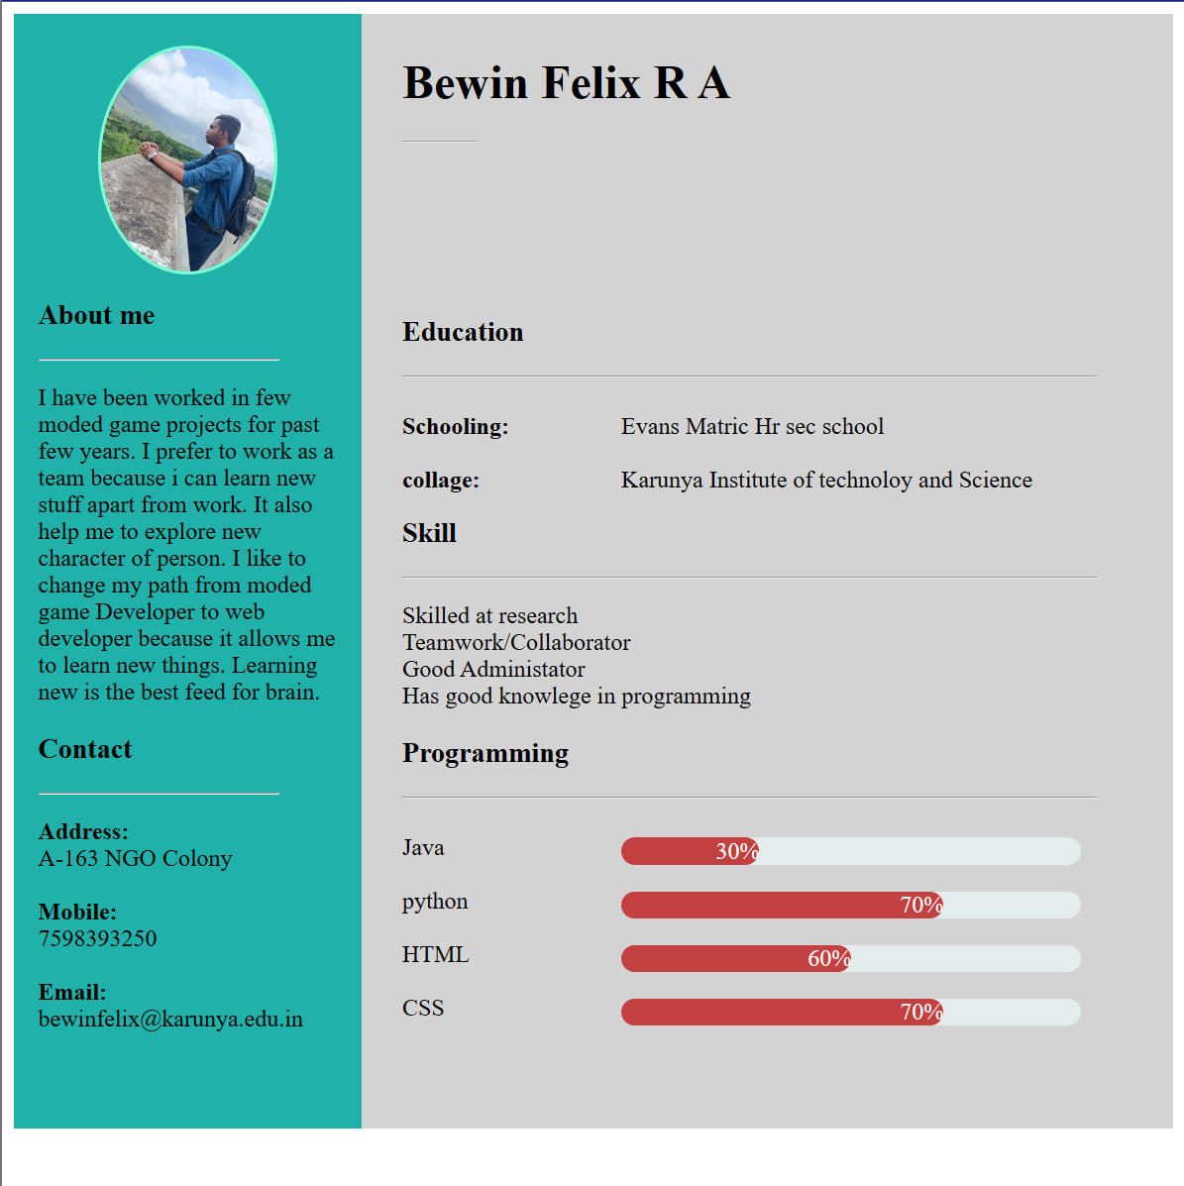

**Result**

The program is executed successfully and the program output is displayed in the web browser.